Project Report

Computer Architecture
Fall 2008

Design of
Instruction Set Simulator & Assembler
for MIPS based assembly language

Department of Electrical and Computer Engineering
University of Florida

Group Members
Madhura Joshi – 6549-3728
Rohit Kumar – 1865-0469
Abelardo Jara-Berrocal – 9190-0969
Arihant Sethia – 4518-3121

- Objective
The aim of this project is to develop an assembler and instruction set simulator for MIPS based custom assembly language. To have in depth knowledge of architecture and implement optimizations, it is essential to first develop an instruction set and its simulator for any the new architecture. With the help of this simulation environment, effect of architectural optimizations can be easily studied. There are two parts in this project. First part involves designing of assembler and instruction set simulator for ones own hardware and instruction set architecture. This architecture has to be optimized and results are to be summarized in a paper during the second part of the project. This project is perfect ground training for the research methodology followed in industry and has helped in depth understanding of computer architecture.

- Overview of Architecture

The architecture chosen for this project implements classic 5 stage pipeline and is RISC architecture.
Program instructions are stored in instruction memory. There is a separate memory for storing data. It is assumed that register file has separate port for read and write. Register write takes place in first half of the clock cycle and read takes place in the later half. Memory latency is assumed to be 0. The clock cycle duration is greater than the longest pipeline stage execution time.
The five stages in pipeline are as follows
- Instruction fetch (IF): In this stage instruction in binary is fetched from instruction memory location according to the value of current program counter. Program counter is incremented to point to next instruction or loaded with appropriate value to fetch branch target.

- Instruction Decode (ID): In this stage fetched instruction is decoded to obtain source and destination registers, immediate value, shift amount and opcodes of instruction. All the potential data and control hazards are detected in this stage. Also branch conditions are evaluated and target PC is calculated. All the source registers are read during this stage. It has a comparator for evaluating branch conditions and adder to calculate address of branch target in case it is a taken branch.

- Execute (EXE): All the instructions are executed in this stage by selecting proper inputs according to type of instruction. There is a multiplier and an adder unit for arithmetic calculations. Control signals are used to decide whether an output should be written in register file.

- Memory (MEM): In this stage data memory is accessed to write or read from any location specified by address in register and/or immediate value. Memory read/write and instruction fetch can take place simultaneously as there is separate memory for data and instruction and separate buses are available.

- Write Back (WB): Result of operation obtained from ALU or result from data memory is written back to register file in this stage.

An instruction takes 5 clock cycles to complete in this pipeline but CPI of the entire program is improved. Some more hardware constructs are:
Pipeline registers: They act as buffers for operands when instruction goes from on cycle to another. They carry both results and control flags.
Register file: Register file consists of 32 registers. Register 0 has fixed value zero. Registers 30 and above are used to hold result of multiplication operation.
All operations take place on 32 bits long data except multiplication operation that operates on 16 bit data.
- Instruction Set Architecture

This architecture has a simple instruction set with fixed 32 bit long instruction. Instruction has a fixed format.
There are only two addressing modes used in this architecture namely register indirect and absolute. Only load and store instructions are used to move data in and out of memory. The instruction types and encoding is described as follows
- Register type instruction (R-type): This type of instructions has both the register operands and result stored in some destination ‘register’. Arithmetic instructions/logical instructions of a particular category have a common op-code and function field value differentiates between the instructions.
- Immediate instructions (I – type): This type of instruction has one register operand and 16 bit immediate field which specifies data.
- J type: Unconditional jump instructions fall in this category. Jump specifies 26 bits of target address.

Instruction encoding and semantics used are summarized in the following table
All the opcodes are specified in decimal format.
R-type instructions: Arithmetic and logical instructions

Way of specification in program |  | Encoding of instruction
Instruction | Semantic | Opcode  6 bits | Rs  5 bits | Rt  5 bits | Rd  5bits | Shift  5bits | Function  6 bits
add | add r3, r1, r2 | 0 | r1 | r2 | r3 | 0 | 32
sub | sub r3, r1, r2 | 0 | r1 | r2 | r3 | 0 | 34
mult | mult r1, r2  Result stored at r30 (fixed) | 0 | r1 | r2 | r1 | 0 | 24
div | div r1, r2  Result stored at r30 (fixed) | 0 | r1 | r2 | r1 | 0 | 26
or | or r3, r1, r2 | 0 | r1 | r2 | r3 | 0 | 37
and | and r3, r1, r2 | 0 | r1 | r2 | r3 | 0 | 36

Immediate type instructions:

Way of specification in program |  | Encoding of instruction
Instruction | Semantic | Opcode  6 bits | Rs  5 bits | Rt  5 bits | Immediate  16 bits | Instruction class
addi | addi r3, r1, imm | 8 | r1 | r3 | imm | Arithmetic  and logical immediate type
ori | ori r3, r1,imm | 13 | r1 | r3 | imm | Arithmetic  and logical immediate type
andi | and r3, r1, imm | 12 | r1 | r3 | imm | Arithmetic  and logical immediate type
load | load r3 , imm(r1) | 35 | r3 | r1 | imm | Memory type
store | Store r3, imm(r1) | 43 | r3 | r1 | imm | Memory type
beq | beq r3, r1, imm | 4 | r1 | r3 | imm | Branch type
bne | bne r3, r1, imm | 5 | r1 | r3 | imm | Branch type
bge | bge r3, r1, imm | 1 | r1 | r3 | imm | Branch type

Jump type instructions:

Way of specification in program |  | Encoding of instruction
Instruction | Semantic | Opcode  6 bits | target address  26 bits
j | j loop | 4 | Address obtained from label loop
exit | exit | 6 | 0
nop | nop | 7 | 0

- Assembler and Simulator Design Methodology

Higher level object oriented language C++ is used for the development of assembler and simulator for the custom instruction set. Visual C++ and Linux, both the platforms are used while developing the code and it is ensured that code is portable between the two platforms with very minor changes.
Separate executable files are created for assembler and simulator which take different command line inputs.

Assembler Development Methodology:
Assembler takes .asm file input from command line. This file contains the program to be executed written in custom assembly language. The output of the assembler is file named Asm_output_(input filename).asm and it is stored in working directory. The output file contains binary string corresponding to each line of assembly language program. The binary strings in the file are printed on new line for easy readability.

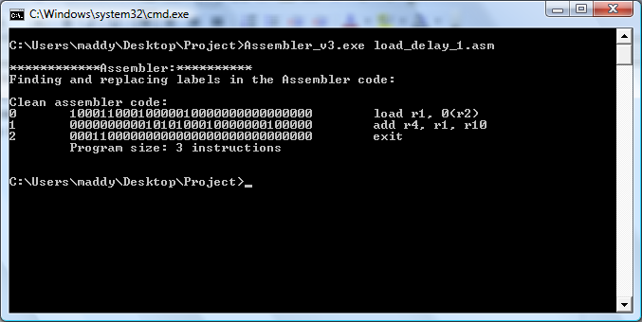
Following steps summarize the algorithm followed in assembler development:
- Read input asm file
- Store the instructions using list of strings.
- While reading the instructions remove the labels.
- Mark instruction which comes after label with label tag.
- Scan again the assembler code list
If instruction is marked with label tag, scan again the list and update the destination field of branch/jump instructions which have that instruction as branch jump target.
- Copy the corrected assembler code list to another final list called asm code
- Parse each instruction and replace each operation and operands by 32 bit fixed binary representation
- Dump the asm code list to asm output file

Instruction Set Simulator (ISS) Development Methodology:
The ISS takes 2 file inputs from command line namely Asm_output_file.asm and memory.mem. The first file contains instruction memory that is program in binary format. This file is output file of the assembler. Memory file contains data to be used for the program. During processor initialization we can specify the size of the data memory, register file as well as instruction memory. The standard configuration used for this hardware is instruction memory of 1000 bytes; data memory of 1500 bytes, register file size of 32.It is assumed that location count of memory starts from 0 for both instruction and data memory. In pipeline, all the stages are executed simultaneously with each stage processing different instruction.

Algorithm used in ISS:
- Start the simulator.
Check if instruction and data memory file inputs are specified. If file inputs are not specified; exit the program with appropriate error message.
If all inputs are found proceed to next step.
- Initialize the processor instruction memory size, data memory size and register file size.
In our case these sizes are fixed to 1000, 1500 and 32 respectively.
- Read data and instruction from data memory and instruction memory files and store them in special data structures used by program. Maximum number of bytes allocated to processor is only loaded from the files.
- Start the simulation.
- Initialize simulation. Contents of pipeline registers, data registers are initialized to 0.Empty instruction memory locations are filled with 'nop' instructions. Enter the fetch stage.
- Check if there are any stall cycles from previous iteration. If there are no stall cycles and no exit instruction is encountered in pipeline, fetch the instruction from PC and increment the PC by 1.

Start the decode stage
- Read the instruction to be decoded from pipeline register. Decode the instruction to get operands, opcode, destination, immediate value, shift amount, target and function code.

Start the execute stage.
- Read the opcode and operands from decode-execute pipeline register. Perform operation to store results in temporary output registers. Start the memory stage.
- If the instruction is of load or store; access the memory to read the memory location or write at the location. Data read from memory is stored in temporary register.

Start the write back stage
- In this stage ALU result or data result is written to the register file.
- Detect the data hazard caused due to load operation and increase the stall count.
- Propagate the values in the pipeline register.
- Detect the pipeline hazards; check RAW hazards. Detect the control hazards in pipeline. Pipeline hazards are checked by comparing values from memory to write back, execute to memory and decode to execute pipeline register parameters. Also forwarding is to be done or not is decided by the opcode of the instruction in pipeline registers which are compared. This simulates register comparison which takes place in hardware decodes stage to detect potential data or control hazards. If instruction to be executed is branch, condition checking happens. If branch is taken branch then target address is sent to PC to fetch the instruction from target. Always instruction next to branch is fetched assuming branch not taken. If branch is found taken, this instruction is flushed or converted to nop.
- Finish
- Check if the exit instruction is encountered in pipeline. If exit instruction is present, allow the pipeline to run for three more cycles in order to complete execution of all instructions currently in the pipeline. Then break the loop. Else go back to step 6.
- Calculate the CPI by checking counter of instruction indicating number of instructions executed and cycles for which pipeline was running
- Print the results of simulation, data memory after simulation and register file contents.
- Simulation end.

Sample output:
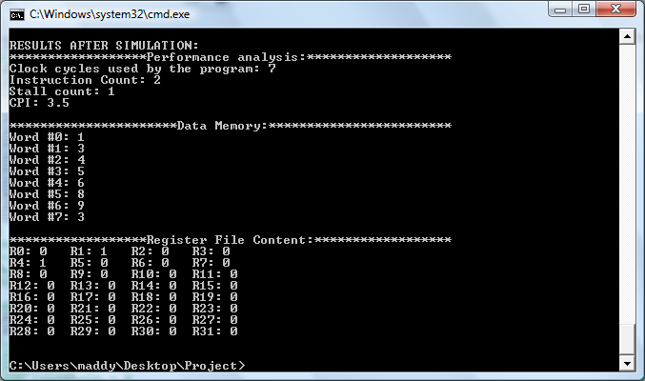
Summary of code structure:
- Assembler
- assembler.cpp: Defines functions to parse data from asm file and convert into binary, results are stored in output asm file.

- ISS
- instruction.h : Defines instruction class with data members which represent binary instruction, literal instruction, source and destination operand registers, shift amount, target address, immediate value
- Member functions operating on these values, used in extraction of these values from binary are declared and defined

- processor.h: Defines class processor. Processor class defines structure of processor including data and instruction memory, register file, pipeline registers, temporary registers
- Member functions operating on this data which carry out simulation, load, and store or show the memory & register contents are declared.

- instruction.cpp: This file contains function definitions for functions in file instruction.h
- processor.cpp: This file contains function definitions for functions in file processor.h
- main.cpp: This file contains the main function which calls various functions from above files to run simulation and store/display results.

- Test Cases and Result
The assembler and simulator are tested with standard test cases provided. All the assembly language programs are modified to run in the new instruction set simulator. The results are agreeing to the results obtained from the standards. In CPI calculations exit instruction is not considered. Summary of results is presented in table below.
CPI Benchmarks | CPI Given | CPI Obtained | Cycles Required | Number of instructions | STALL Count | Remarks
Load_delay_1 | 3.5 | 3.5 | 7 | 2 | 1 | Ok
Load_delay_2 | 3.5 | 3.5 | 7 | 2 | 1 | Ok
Load_delay_3 | 3.5 | 3.5 | 7 | 2 | 1 | Ok
Load_reg_1 | 1.8 | 1.8 | 9 | 5 | 0 | Ok
Load_reg_2 | 1.8 | 1.8 | 9 | 5 | 0 | Ok
Load_reg_3 | 1.8 | 1.8 | 9 | 5 | 0 | Ok
Alu_reg_1 | 1.8 | 1.8 | 9 | 5 | 0 | Ok
Alu_reg_2 | 1.8 | 1.8 | 9 | 5 | 0 | Ok
Alu_reg_3 | 1.8 | 1.8 | 9 | 5 | 0 | Ok
Ex-mem_to_ex_1 | 2.33 | 2.33 | 7 | 3 | 0 | Ok
Ex-mem_to_ex_2 | 2.33 | 2.33 | 7 | 3 | 0 | Ok
Ex-mem_to_ex_3 | 2.33 | 2.33 | 7 | 3 | 0 | Ok
Mem-wb_to_ex_1 | 2.33 | 2.33 | 7 | 3 | 0 | Ok
Mem-wb_to_ex_2 | 2.33 | 2.33 | 7 | 3 | 0 | Ok
Mem-wb_to_ex_3 | 2.33 | 2.33 | 7 | 3 | 0 | Ok
Mem-wb_to_ex_4 | 2.33 | 2.33 | 7 | 3 | 0 | Ok
Mem-wb_to_ex_5 | 2.33 | 2.33 | 7 | 3 | 0 | Ok
Mem-wb_to_ex_6 | 2.33 | 2.33 | 7 | 3 | 0 | Ok
St_mem-wb_mem | 2.33 | 2.33 | 7 | 3 | 0 | Ok
St_addr_ex-mem_ex | 2.33 | 2.33 | 7 | 3 | 0 | Ok
St_addr_mem-wb_ex | 2.33 | 2.33 | 7 | 3 | 0 | Ok
ld_addr_ex-mem_ex | 2.33 | 2.33 | 7 | 3 | 0 | Ok
ld_addr_mem-wb_ex | 2.33 | 2.33 | 7 | 3 | 0 | Ok
Ld_st_mem-wb_mem | 2.33 | 2.667 | 8 | 3 | 1 | Difference in CPI is due to the stall cycle.
Big_test | 1.8 | 1.8 | 9 | 5 | 0 | Ok
Branch_1 | 3 | 2.667 | 8 | 3 | 0 | Branch detection and decision is taken in decode stage. So the difference in CPI. 1 cycle is wasted in flushing the pipeline
Branch_2 | 2.5 | 2.25 | 9 | 4 |  | Branch detection and decision is taken in decode stage. So the difference in CPI. 1 cycle is wasted in flushing the pipeline
mult |  | 1.073 | 1382 | 1288 | 64 | Ok
matrix |  | 1.0339 | 365 | 353 | 0 | Ok
memmove |  | 1.3 | 280 | 215 | 21 | Ok
array |  | 1.08 | 512 | 474 | 30 | Ok
gcd |  | 1.333 | 28 | 21 | 0 | Ok

- Custom Benchmarks

ISS and assembler are tested with 2 custom benchmarks. These benchmarks require varied combinations of basic operations. Successful execution of this benchmarks will assure that the hazards are handled and pipelining is implemented in right way.
  - Benchmarks chosen
- Generation of n^{th} term of Fibonacci series
- Checking divisibility of number by 3

Results obtained

CPI Benchmarks | CPI Obtained | Cycles Required | Number of instructions | STALL Count | Remarks
Generation of nth term of Fibonacci series | 1.264 | 43 | 34 | 0 | Ok
Checking divisibility of number by 3 | 1.5 | 36 | 24 | 0 | Ok

- Conclusion

Working on this project was a great learning experience. While studying any computer architecture, one is not able understand the intricacies in data path design completely. We are able to understand concepts in better way by working on this project. It has also enhanced our application knowledge of C++ language and platforms used. We are looking forward to make our project and instruction set more efficient by implementing optimizations in architecture.

